Fellow Name: Kelsey Baum | Contact Info: 513-478-4758 | Date: 12/30/14
Teacher Name: Deon Edwards | School Name: Aiken High School | Grade and Class: Freshman/Engineering

Activity Title: | Make your own Generator and Motor
Estimated Activity Duration: | 1-2 classes

Setting: | Classroom

Activity Objectives:

The student will be able to:

- Use a multi-meter to measure voltage and current.
- Describe what a generator does and how it works
- Describe what a motor does and how it works.
- Identify energy transformations from the energy source to various appliances.
Activity Guiding Questions:

1. What are the different energy sources that are used to deliver energy to your community?
2. How do power plants turn coal into electricity?
3. What is the difference between a motor and a generator?
4. What kinds of energy transformations take place between power plants and using your appliances?
Next Generation Science Standards (NGSS)
Science and Engineering Practices (Check all that apply) | Crosscutting Concepts (Check all that apply)
☐ Asking questions (for science) and defining problems (for engineering) | ☒ Patterns
☐ Developing and using models | ☒ Cause and effect
☐ Planning and carrying out investigations | ☐ Scale, proportion, and quantity
☐ Analyzing and interpreting data | ☒ Systems and system models
☒ Using mathematics and computational thinking | ☒ Energy and matter: Flows, cycles, and conservation
☐ Constructing explanations (for science) and designing solutions (for engineering) | ☐ Structure and function.
☐ Engaging in argument from evidence | ☐ Stability and change.
☐ Obtaining, evaluating, and communicating information

Ohio’s New Learning Standards for Science (ONLS)
Expectations for Learning - Cognitive Demands (Check all that apply)
☐ Designing Technological/Engineering Solutions Using Science concepts (T)
☒ Demonstrating Science Knowledge (D)
☒ Interpreting and Communicating Science Concepts (C)
☒ Recalling Accurate Science (R)

Common Core State Standards -- Mathematics (CCSS)
Standards for Mathematical Practice (Check all that apply)
☐ Make sense of problems and persevere in solving them | ☒ Use appropriate tools strategically
☐ Reason abstractly and quantitatively | ☐ Attend to precision
☐ Construct viable arguments and critique the reasoning of others | ☐ Look for and make use of structure
☐ Model with mathematics | ☒ Look for and express regularity in repeated reasoning

Unit Academic Standards (NGSS, ONLS and/or CCSS):

9th grade Engineering Science
Topic: Electricity and Electrical Systems
Content Statement:

In earlier grades, these concepts were introduced: electrical conductors and insulators; and a complete loop is needed for an electrical circuit that may be parallel or in a series. In this course, circuits are explained by the flow of electrons, and current, voltage and resistance are introduced conceptually to explain what was observed in middle school. The differences between electrical conductors and insulators can be explained by how freely the electrons flow throughout the material due to how firmly electrons are held by the nucleus. By convention, electric current is the rate at which positive charge flows in a circuit. In reality, it is the negatively charged electrons that are actually moving. Current is measured in amperes (A), which is equal to one coulomb of charge per second (C/s). In an electric circuit, the power source supplies the electrons already in the circuit with electric potential energy by doing work to separate opposite charges. For a battery, the energy is provided by a chemical reaction that separates charges on the positive and negative sides of the battery. This separation of charge is what causes the electrons to flow in the circuit. These electrons then transfer energy to other objects and transform electrical energy into other forms (e.g., light, sound, heat) in the resistors. Current continues to flow, even after the electrons transfer their energy. Resistors oppose the rate of charge flow in the circuit. The potential difference or voltage across an energy source is a measure of potential energy in Joules supplied to each coulomb of charge. The volt (V) is the unit of potential difference and is equal to one Joule of energy per coulomb of charge (J/C). Potential difference across the circuit is a property of the energy source and does not depend upon the devices in the circuit. These concepts can be used to explain why current will increase as the potential difference increases and as the resistance decreases. Experiments, investigations and testing (3-D or virtual) must be used to construct a variety of circuits, and measure and compare the potential difference (voltage) and current. Electricity concepts are dealt with conceptually in this course. Calculations with circuits will be addressed in the physics syllabus.

Materials: (Link Handouts, Power Points, Resources, Websites, Supplies)

Ceramic Magnets (1x2x5 cm)
Magnet Wire (#30)
Cardboard strips
Sandpaper
Multimeters
Large nails or pins
D-cell batteries
Markers
Electrical tape
Modeling Clay

Teacher Advance Preparation:

Watch youtube videos on making a generator and motors for high school students.

Assemble directions for how to make generator and motor and make copies for classroom.
Gather supplies for activity and cut out cardboard pieces for each group

Make ahead a generator and motor to make sure the activity works.

Activity Procedures:

Give pre-assessment hand-out and allow kids 2 minutes to complete.

Show and explain the image below, How coal becomes electricity.
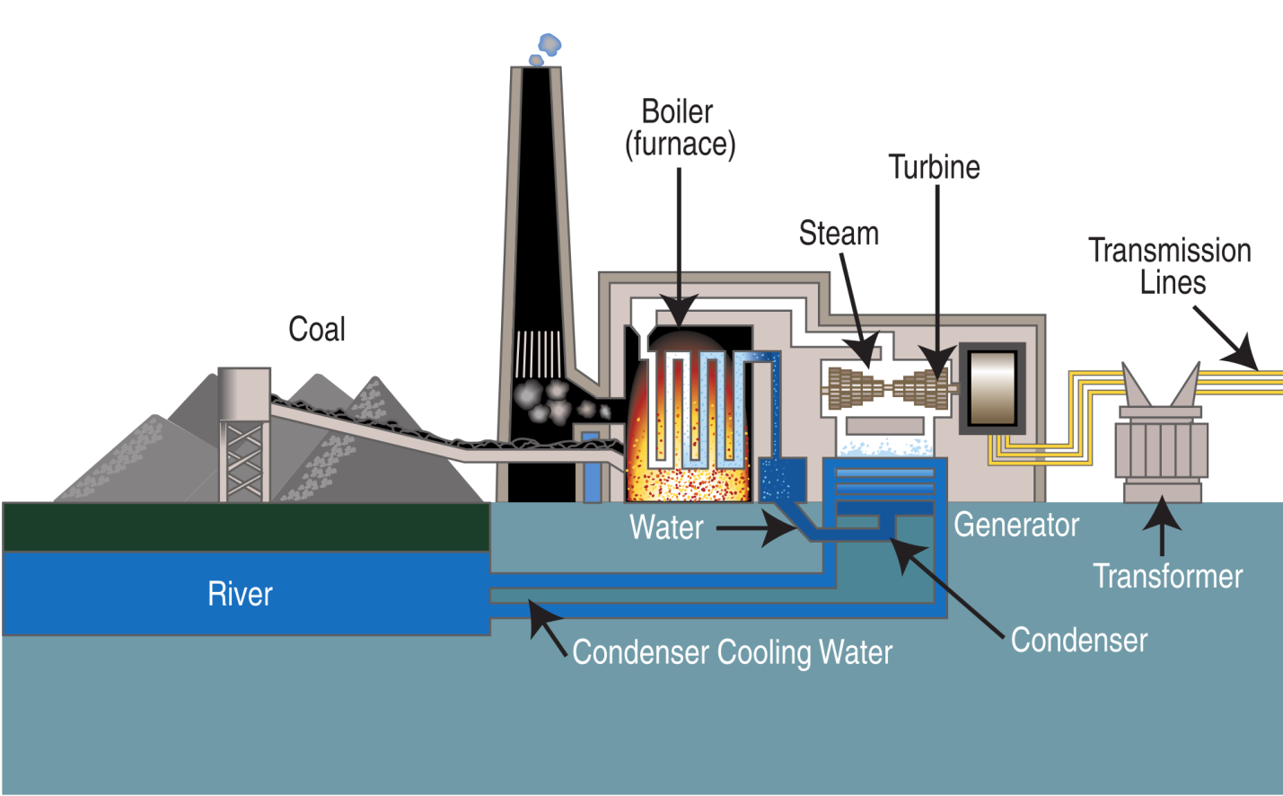

Then explain as electricity goes to your house, it is transformed by motors into mechanical energy.

Give examples of motors and ask students to give examples of motors and what they do.
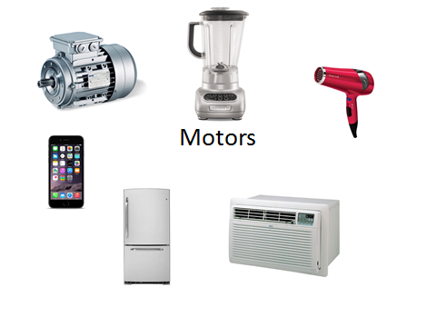
Split students into groups of 4 and handout supplies and pass out “Generator/Motor Activity Checklist.” Sheets and directions for how to make a Generator/Motor.

Walk around checking groups on their “Generator/Motor Activity Checklist.”

Generator:

- Take cardboard box piece and stick pin through the middle of it. Wiggle pin so that the pin spins easily in the cardboard.
- Stack two sets of two magnets and place under and above the metal pin in the cardboard.
- Take one end of wire and wrap wire 60 times around the cardboard enclosure middle. (The pin will divide the wire on both sides of it).
- Cut end of wire to hang some hanging off.
- Sandpaper the ends of the wire.
- Connect ends to voltmeter.
- Crank the metal pin and view voltmeter readings.
Show them how to measure their circuit using a multimeter.

Walk around checking groups on their “Generator/Motor Activity Checklist.”

Motor:

- Starting at center of wire, wrap wire around marker 30 times.
- Slide coil off marker, and wrap each loose end around the coil a few times to hold the loop.
- Using sandpaper, sand the top half of insulation off the wire on both sides.
- Thread each loose end of wire coil through two metal pins, keeping the coil as straight as possible.
- Lay D-battery sideways on flat surface.
- Stick some modeling clay on either side of battery to keep it from moving.
- Take two small balls of modeling clay and cover sharp ends of pins.
- Place needles upright next to terminals of the battery, ensuring the needles are touching the terminals.
- Use electrical tape to secure the needles on the terminal.
- Tape the small magnet to the side of the battery so that it is centered under the coil.
- Give your coil a spin.
Allow 2 minutes and give post assessment.

Formative Assessments: Link the items in the Activities that will be used as formative assessments.

As students are working on the activity, I will check their group checklist at their table to make sure they complete each step. As seen below:

Generator/Motor Activity

Name ___________________________________ Group Members:

Directions: Please have Ms. Baum initial your checkpoint as you complete each section below.
Section 1: Construct the generator. ___________ checkpoint
Section 2: Attached wires to multimeter and obtain reading. ___________ checkpoint
Voltage reading _____________
Current reading _____________ ___________ checkpoint
Section 4: Construction of motor. ___________ checkpoint
Describe the differences between a motor and a generator: ______________________________
_____________________________________________________________________________
_____________________________________________________________________________

Summative Assessments: Prepare a Pre-Test and Post-Test with the input of the RET Teacher. This should be a simple 10-12 question assessment tool. These questions will cover the content related to the Standards. The Pre and Post Test will be identical. There may be several summative assessments at the end of this Activity. Besides the Pre and Post Tests, the students might create a product for which this is a rubric developed. The rubric is also a summative assessment tool. Link the assessment tools.

Pre-test and Post-test will be a series of 4 questions regarding material of the activity in class.

Pre-assessment and Post-assessment
What is a motor?
a. machine that converts wind to electrical energy
b. machine that converts electrical to mechanical energy
c. machine that converts chemical to electrical energy

What is a generator?
a. machine that converts mechanical to electrical energy
b. machine that converts chemical energy to electrical energy
c. machine that converts mechanical to chemical energy

What is voltage?
a. The rate at which charge is flowing
b. Material’s tendency to resist flowing charge
c. Difference in charge between two points

What is current?
a. The rate at which charge is flowing
b. Material’s tendency to resist flowing charge
c. Difference in charge between two points

Differentiation: Describe how you modified parts of the Lesson to support the needs of different learners. Refer to Activity Template for details.

Some of the groups were able to read the directions for making the generator and motor, but some are more auditory learner. I read the directions step by step to a few of the groups that were not quite sure how to get started.
Reflection: Reflect upon the successes and shortcomings of the Activity. This is done after the Activity is implemented.

The activity was planned for one day, but in implementation it took about two to complete. I forgot to give them the Motor appliances activity sheet. Some groups were unable to decipher the typed directions for assignment, so maybe in the future there could be pictures of the step by step process. Many students liked the checklist involved. I did not have enough magnet wire but there was back-up in the classroom. In the future the students could have grasped the concept of how a motor/generator works instead of just focusing on the construction. To achieve this, students could have constructed the motor and generator, then be given time to use the internet and research how motors and generators work (retrograde approach). The pre and post assessment graphs are shown below:

For the pre and post-test analysis, I used the information from the students that took both, the pre-test and post-test, since some students who were there the first day weren’t there the second, and vice versa. Through the analysis, the post-test had a higher number of three and four answers correct and a lower number of zero, one, and two answers correct.

